**PH160 laboratory session 1**

Name : Snehal Nalawade

Student ID : 202151160

**Aim** : To verify Newton’s second law of motion

**Theory** : Newton’s second law states that the acceleration(a) of a body/system is directly proportional to the net force acting on it and inversely proportional to the mass of the body/system.

The system used in this experiment consists of a cart(M) kept on a horizontal table of coeff. of friction u and tied by an inextensible string to a hanging wt.(m) which is held in hand and released as soon as the experiment starts.

In order to verify newton’s second law, the value of a is calculated using this law and checked if it is equal to the value observed during the experiment, for different values of masses and coeff. of friction. if the value of a is equal in every case, then newton’s second law is verified.

**Observation table** :

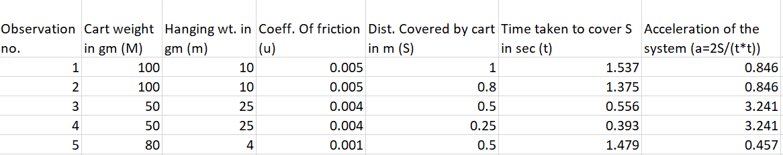

**Calculation** : Let’s assume that Newton’s second law of motion is valid;

so, F(net) = ma

Therefore, in the given System of cart and hanging wt.,

T – f = M*a …………(1)

where T= tension in the string

f = frictional force on cart (M) = u*M*g

a = acceleration of the entire system

In case of the hanging wt. (m),

m*g – T = m*a …………….(2)

Substituting the value of T from (2) in (1) , we get,

a = {(m – u*M) *g} / (m + M) …..(3)

where u = coeff. Of friction of the table

now we will calculate acceleration of the system for different values of m,M,u ,S and t using eqn. (3) :

Note : in each case, since u is constant througout the surface, therefore ‘a’ will be independent of S and t (because the frictional force between a surface and body is independent of the body’s velocity as long as the magnitude of velocity is not very high)

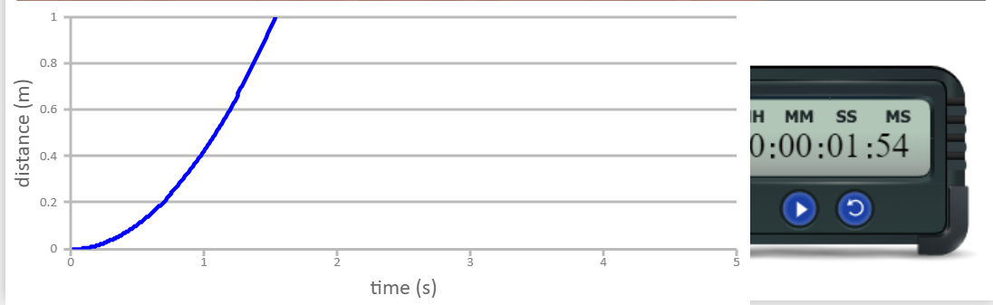 observation no. 1 and 2 --- m = 0.01 kg, M = 0.1 kg, u = 0.005

a = {( 0.01 – 0.005*0.1)*9.8} / (0.01 + 0.1)

a = 0.846

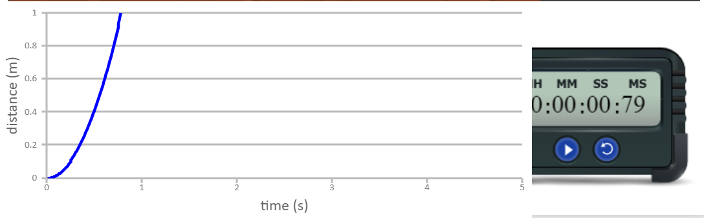

observation 3 and 4 --- m = 0.025 kg, M = 0.05 kg, u = 0.004

a = {(0.025 – 0.004*0.05)*9.8} / (0.025 + 0.05)

a = 3.240

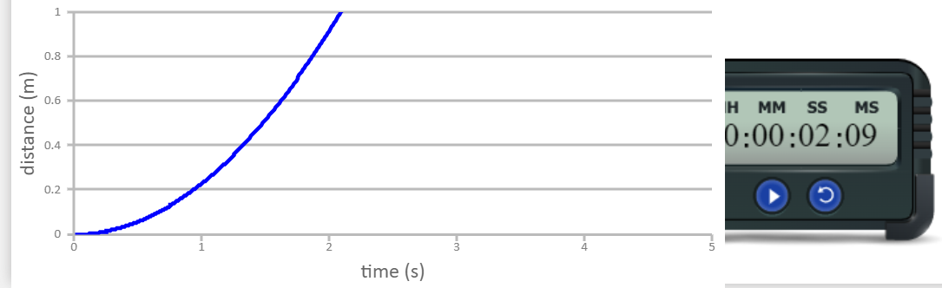

observation 5 --- m = 0.004 kg, M = 0.08 kg, u = 0.001

a = {(0.004 – 0.001*0.08)*9.8} / (0.004 + 0.08)

a = 0.457

**Error in Result** : No Error is observed during the experiment (since simulator was used).

**Result Analysis** : Since the value of acceleration that we obtain by calculating using newton’s second law of motion in every case is equal to the value of acceleration observed during the experiment, therefore the assumption made initally is true and therefore Newton’s second law of motion is verified.

**Thank you**